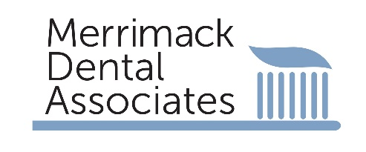

Dear Valued Patient:
We hope this letter finds you and your family in good health. Our community has been through a lot over the last few months, and all of us are looking forward to resuming our normal habits and routines. While many things have changed, one thing has remained the same: our commitment to your safety.
Infection control has always been a top priority for our practice and you may have seen this during your visits to our office. Our infection control processes are made so that when you receive care, it’s both safe and comfortable. We want to tell you about the infection control procedures we follow in our practice to keep patients and staff safe.
Our office follows infection control recommendations made by the American Dental Association (ADA), the U.S. Centers for Disease Control and Prevention (CDC) and the Occupational Safety and Health Administration (OSHA). We follow the activities of these agencies so that we are up-to-date on any new rulings or guidance that may be issued. We do this to make sure that our infection control procedures are current and adhere to each agencies’ recommendations.
You may see some changes when it is time for your next appointment. We made these changes to help protect our patients and staff. For example:
- Our office will communicate with you beforehand to ask some screening questions. You’ll be asked those same questions again when you are in the office.
- We have hand sanitizer that we will ask you to use when you enter the office. You will also find some in the reception area and other places in the office for you to use as needed.
- You may see that our waiting room will no longer offer magazines, children’s toys and so forth, since those items are difficult to clean and disinfect.
- Appointments will be managed to allow for social distancing between patients. That might mean that you’re offered fewer options for scheduling your appointment.
- We will do our best to allow greater time between patients to reduce waiting times for you, as well as to reduce the number of patients in the reception area at any one time.
We look forward to seeing you again and are happy to answer any questions you may have about the steps we take to keep you, and every patient, safe in our practice. To make an appointment, please call our office 603-424-6131.
Thank you for being our patient. We value your trust and loyalty and look forward to welcoming back our patients, neighbors and friends.
Sincerely,
Drs Herod & Antonsson & the staff at Merrimack Dental Associates

